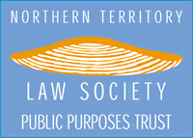 | 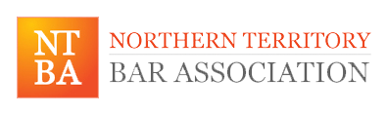 | 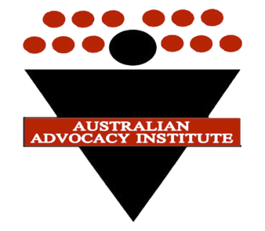
2014 NTBA Readers’ Course
The NTBA, in conjunction with the Australian Advocacy Institute, and with the generous support of the NT Law Society Public Purposes Trust, are presenting the inaugural NTBA Readers’ Course. The course will commence with an introductory session on the evening of Friday 18 July and then run from Monday 21 July to Saturday 26 July 2014. Some additional follow up course work will also be required.
This intensive course is open to:
• Northern Territory barristers and those applying to the NT Bar
• Practitioners employed by the NT DPP and NT Legal Aid organisations
• Resident Northern Territory Solicitor Advocates
• Advocates from international jurisdictions.
This course has been designed by senior members of the AAI faculty in compliance with world best practice and is based on experience over many years in teaching at similar courses both in Australia and overseas. The moderators of the course will be Prof George Hampel and Justice Ann Ainslie-Wallace. The course will be presented principally by the moderators and other AAI instructors with additional support from senior members of the NTBA.
COMPONENTS
The course will focus on the fundamentals of persuasive advocacy including the following components:
- method of systematic preparation  - case analysis  - performance preparation  - communication skills  - specific advocacy skills in opening addresses, examination in chief, cross examination and re-examination | - taking and arguing objections  - argument  - pleas in mitigation  - expert evidence  - applications  - pleadings  - written summaries of argument  - ethics in advocacy
Selected performances will be filmed and feedback given. The cost of the course is $3,000 including GST. A limited number of positions are available so register soon at: www.advocacy.com.au.

